The Linux file system follows a hierarchical structure, organized in a tree-like format. While it can vary slightly between distributions, here's a typical overview of the Linux file system structure:  
  
  
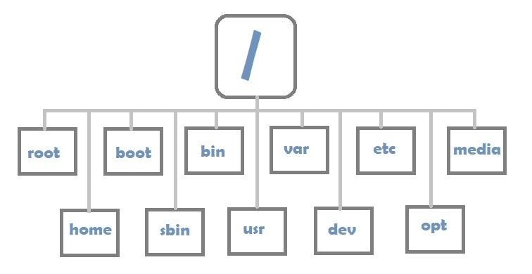

1. \*\*Root Directory ("/"):\*\* At the top of the hierarchy is the root directory, represented by a forward slash ("/"). Everything in the file system is stored under this directory.

2. \*\*/bin (Binary Binaries):\*\* Contains essential binary executables (commands) needed for system boot and repair. Common commands like ls, cp, and mv reside here.

3. \*\*/boot:\*\* Contains files required for booting the operating system, including the kernel, bootloader configuration, and initial RAM disk (initrd) images.

4. \*\*/dev (Devices):\*\* Houses device files that represent physical and virtual devices on the system, allowing interaction with hardware components like disks, terminals, and USB devices.

5. \*\*/etc (Etcetera):\*\* Stores system-wide configuration files for various applications, services, and the operating system itself. Configuration files for networking, user authentication, and software packages typically reside here.

6. \*\*/home:\*\* User home directories are usually located here. Each user has a subdirectory within /home to store personal files and configurations.

7. \*\*/lib (Libraries):\*\* Contains essential system libraries needed by binaries in /bin and /sbin. These libraries provide core functionality to applications and system utilities.

8. \*\*/media and /mnt (Mount Points):\*\* Directories used as mount points for external devices such as USB drives, CD-ROMs, and network shares.

9. \*\*/opt (Optional):\*\* Often used for installing optional or third-party software packages. Some applications and software might have their directories within /opt.

10. \*\*/proc and /sys:\*\* Special virtual file systems that provide information about system processes (/proc) and kernel data (/sys). They don't store physical files but instead present information as files for system monitoring and configuration.

11. \*\*/root:\*\* Home directory for the root user. Unlike regular users who have home directories under /home, the root user's home directory is located here.

12. \*\*/sbin (System Binaries):\*\* Contains essential system administration binaries, usually reserved for superuser (root) commands necessary for system maintenance.

13. \*\*/srv (Service):\*\* Contains data for services provided by the system, often used by servers to store data related to specific services like HTTP (web server) or FTP (file transfer).

14. \*\*/tmp (Temporary):\*\* Used for temporary file storage by applications and users. Files in /tmp are typically deleted upon system reboot.

15. \*\*/usr (Unix System Resources):\*\* Contains user-related programs, libraries, documentation, and resources not required for system booting.

16. \*\*/var (Variable):\*\* Stores variable data such as log files, spool files, temporary files generated by users, and other system-generated data that might change during the system's operation.

This hierarchical structure allows for organized storage of files, system configuration, and user data in a way that's easily navigable and manageable.